Activity 1 : Self test diagnostic sheet

Diagnosing problems based on the robot failing the self-test

You have a robot that has failed the self test activity. The following will help to find out the problem.

- FIVE ✓‘s means all is fine and the motor wiring is correct.
  - Now remove the wire links and store in your kit box. You can always rerun the test if you feel that the robot is not working correctly.
- Test 1 fail
  - Check batteries are correctly inserted and rerun the test.
  - Try different set of batteries and rerun test.
    - If successful recharge batteries.
- Test 2 fail
  - Faults in switches or LEDs
    - Use spare robot and return original for repair.
- Test 3 fail
  - Like to be a wiring problem.
    - Make sure the LEFT motor is wired to the left connector.
    - Make sure the RIGHT motor is wired to the right connector
    - BLACK wires connect to connector-1
    - RED wires connect to connector-2
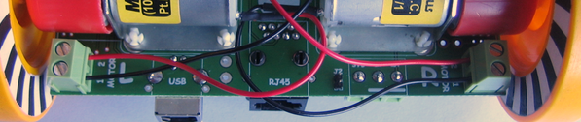
Black wire from LEFT motor
Black wire from RIGHT motor
Red wire from LEFT motor
Red wire from RIGHT motor

- Test 4 fail
  - Again, likely to be a wiring problem. See Test 3 fail information.

- Test 5 fail
  - Check that POTS point exactly to the battery as in following picture, then rerun test.
  - A similar test failure means that there is a problem with the robot hardware.
    - Use spare robot and return original for repair

