Activity 1 : Self test sheet

Aim
To ensure that the robot is built and wired correctly and that there are no hardware faults in the robot.

Preparation
Add TWO wire links to the robot as follows
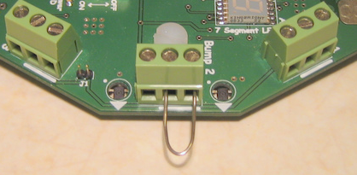
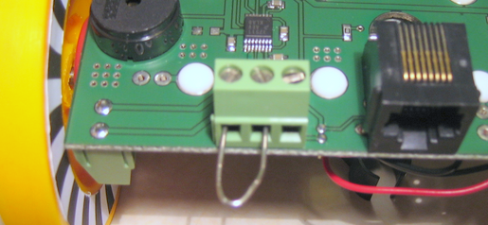

Front link
Back link

The links are provided in a pack in your teacher’s kit. The pack is labelled “wire links”.

Running the test
Put a ✓ or a  in the last column if the test was successful or failed.
Test | Action | Comments | ✓or 
1. | Place robot on the floor and switch on. | Display should shows the message  tESt8
 | Press any switch to continue to the next test. |  | ------
2. | As each LED comes ON press the switch below  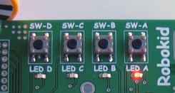 | LED A comes On → press SW-A  LED B comes On → press SW-B  LED C comes On → press SW-C  LED D comes On → press SW-D  Tests the four LEDs and the four switches
3. | Ensure robot is on the floor then press switch A | Robot should move forward for 5 seconds
4. | Press switch A | Robot should turn left for 3 seconds
 |  | Display will now show the message  SEt POtS | ----
5. | Set all 3 POTs to point to the batteries.  Then press switch A  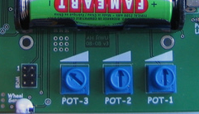 | If successful the display will show  tESt_End  If there is a problem the display will show  Err_Pot_1 or 2 or 3
If five ✓‘s then robot works and is correctly wired. If any ‘s then get copy of diagnostic sheet from your teacher.

